Fossils-Burgess shale-like- Paralejurus

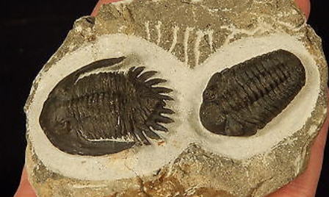

Hollardops mesocristata?? Moroccan Trilobite Fossil specimen with a Paralejurus Rehamnanus ? trilobite next to it all in there AM Limestone? Formation matrix.... a Beautiful Piece!!

This "rock" was a living animal during the Devonian Era around 419 to 358 million years ago!

The largest trilobite measures 3.7cm or 1 7/16" and the overall matrix piece measures about 8.9cm or 3 1/2" at its biggest!